ASSISTANCE TO INDIVIDUAL IN CRISIS SITUATION
HOSPITAL ASSISTANCE
April 16, 2026

DR. DIGNA RAGASA
Hospital Administrator
Metro Vigan Hospital
Bantay, Ilocos Sur

Ma’am:

The undersigned would like to ask for your favorable assistance to Irene Ragonton, 72 years old of Barangay Tamag, Vigan City who was confined thereat.

In this regard, may I request you to deduct the amount of FIFTEEN THOUSAND PESOS ONLY (P15,000.00) from the payment of her hospital bill chargeable to Assistance to Individual in Crisis Situation Program of the City Government.

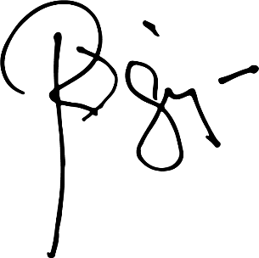
Truly yours,

HON. RANDOLF “RANDY” V. SINGSON

Control No.090H-2026

CERTIFICATION

This is to certify that the assistance to Irene Ragonton, 72 years old of Barangay Tamag, Vigan City Ilocos Sur who was examined by the hospital. The said patient consumed the amount of FIFTEEN THOUSAND PESOS ONLY (P15,000.00) for the service guaranteed for payment by the City Government of Vigan.

Conforme:

JOEL RAGONTON ______________________
Son Signature over Printed Name
(Representative of the Hospital)

Control No. 090H-2026

